|  |
| --- |
| **Philly CRM 311**  **Technical Design – Illegal Dumping**  **V1.1** |
|  |

# REVISION HISTORY

|  |  |  |  |
| --- | --- | --- | --- |
| **Revision Number** | **Revision Date** | **Summary of Changes** | **Author** |
| Draft | 01/25/2014 | Created Draft | Murugaboopathi |
| 1.0 | 02/09/2014 | Updated based on review/updated SR | Murugaboopathi |
| 1.1 | 04/16/2014 | Updated based on review/updated SR 1.7 | Murugaboopathi |

# 1 - TABLE OF CONTENTS

REVISION HISTORY 2

1 - TABLE OF CONTENTS 3

2 – SERVICE REQUEST INFORMATION 4

2.1 ENTITY RELATIONSHIP DIAGRAM 5

2.2.1 CASE STANDARD FIELDS FOR ILLEGAL DUMPING 6

2.2.2 CASE ADDITIONAL FIELDS FOR ILLEGAL DUMPING 6

2.2.2 Force.com Objects 8

2.3 HIGH LEVEL SYSTEM PROCESS FLOW 8

3 - NEW FUNCTIONALITY 10

3.1 CONFIGURATION DETAILS 10

3.2 DATA SHARING MODEL 13

3.3 CUSTOM DEVELOPMENT DETAILS 13

4 – STANDARD CASE FIELDS 17

4.1 DEPARTMENT DETAILS SECTION 18

4.2 CASE DETAIL/INFORMATION SECTION 19

4.3 SERVICE REQUEST LOCATION SECTION 21

4.4 CASE LOCATION SECTION 22

4.5 DESCRIPTION INFORMATION SECTION 22

4.6 RESOLUTION INFORMATION SECTION 23

4.6 WEB INFORMATION SECTION 24

4.7 SYSTEM INFORMATION SECTION 24

# 2 – SERVICE REQUEST INFORMATION

|  |  |
| --- | --- |
| **Case Record Type :** | Illegal Dumping |
| **Service Request ID** | SR-ST02: Illegal Dumping |
| **Service Request Type** | Illegal Dumping |
| **Department** | Streets |

|  |
| --- |
| 2.1 ENTITY RELATIONSHIP DIAGRAM |

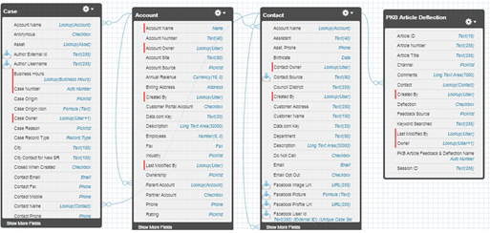

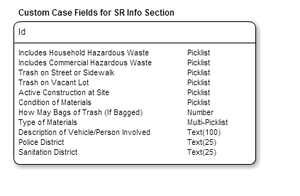

|  |
| --- |
| 2.2.1 CASE STANDARD FIELDS FOR ILLEGAL DUMPING |

|  |  |  |  |  |  |  |  |  |  |
| --- | --- | --- | --- | --- | --- | --- | --- | --- | --- |
| **Field Label** | **Field Name** | **Data Type** | **Required** | **Unique** | **Default Value** | **External ID** | **Rule #** | **History** | **Help Text** |
| Status | Status | Picklist  Values: New, In-Progress, Escalated, On Hold, and Closed | Yes | No | New | No | None | Yes |  |
| Case Origin | Origin | Picklist  Values: Phone, Email, Web | Yes | No | Phone | No | None | Yes |  |
| Priority | Priority | Picklist  Values: High, Medium, Low | Yes | No | Medium | No | None | Yes |  |

|  |
| --- |
| 2.2.2 CASE ADDITIONAL FIELDS FOR ILLEGAL DUMPING |

|  |  |  |  |  |  |  |  |  |  |
| --- | --- | --- | --- | --- | --- | --- | --- | --- | --- |
| **Field Label** | **Field Name** | **Data Type** | **Required** | **Unique** | **Default Value** | **External ID** | **Rule #** | **History** | **Field Help Text** |
| Includes Household Hazardous Waste | Trash_Include_Household_Hazardous_Waste__c | Picklist  Values: Yes, No | Yes |  |  |  | Workflow Rule #1 | No | Household Hazardous Waste includes: oil based paint, fluorescent light tubes, Compact Fluorescent Lights (CFLs), computer equipment, TVs. |
| Includes Commercial Hazardous Waste | Trash_Include_Commercial_Hazardous_Waste__c | Picklist  Values: Yes, No | Yes |  |  |  | Workflow Rule #2 | No | Commercial Hazardous Waste includes: chemical waste, spilled oil, abandoned oil drums |
| Trash on Street or Sidewalk | Is_Trash_on_Street_or_Sidewalk__c | Picklist  **Values:** Yes, No | Yes |  |  |  | Workflow Rule #3 | No | Is it a public right-of-way for pedestrians or vehicles? |
| Trash on Vacant Lot | Is_Trash_on_Vacant_Lot__c | Picklist  **Values:** Yes, No | Yes |  |  |  | Workflow Rule #4 | No | Is the trash dumped on a parcel of land with no standing structure? |
| Active Construction at Site | Is_there_active_construction_at_the_site__c | Picklist  **Values:** Yes, No | Yes |  |  |  | Workflow Rule #5 | No | Have construction crews and vehicles been present at the site within the last week? |
| Condition of Materials | Condition_of_Materials__c | Picklist  **Values**: Bagged, Container, Litter, Construction Debris | Yes |  |  |  | None | No | Is the trash in bags or a container or is it loose (litter)? If loose is the debris construction material? |
| How May Bags of Trash (If Bagged) | How_May_Bags_of_Trash_If_Bagged__c | Number | No |  |  |  | None | No | If the trash is in bags, how many bags are there (estimate)? |
| Type of Materials | Type_of_Materials__c | Multi-Picklist  **Values:** Construction Material, Appliances, TV’s and Monitors, Mattress/Furniture, Other | Yes |  | No |  | None | No | Were construction materials illegally dumped (bricks, concrete, drywall, other remodeling house setouts, etc.)? |
| Description of Vehicle/Person Involved | Description_of_Vehicle_Involved_in_Dumpi__c | Text(100) | No |  |  |  | None | No | Description of the person or vehicle and plate information such as licensing state and tag number, if known. |
| Police District | Police_District__c | Text(25)  Auto-populated. | Yes |  |  |  | Workflow Rule #6 | No | The police district in which the illegal dumping occurred. |
| Sanitation District | Sanitation_District__c | Text(25)  Auto-populated. | Yes |  |  |  | Workflow Rule #7 | No | In which sanitation district was the incident reported? |

|  |
| --- |
| 2.2.2 Force.com Objects |

|  |  |  |
| --- | --- | --- |
| **Custom/Standard** | **Existing Objects** | **New Objects** |
| Standard | Case |  |
| Standard | Account |  |
| Standard | Contact |  |
| Custom | PKB Article Deflection |  |

|  |
| --- |
| 2.3 HIGH LEVEL SYSTEM PROCESS FLOW |



# 3 - NEW FUNCTIONALITY

|  |
| --- |
| 3.1 CONFIGURATION DETAILS |

**Record Types :** *Illegal Dumping in* ***Case*** *Object*

**Case Record Type:** *Illegal Dumping*

Label: Illegal Dumping

Support Process: Case Support Process

Support Process Selected Values:

* New (Default)
* In-Progress
* Escalated
* On-Hold
* Closed(Closed)
* Completed

Record Type Name: Illegal_Dumping

**Buttons:**

* Case Edit
  + Save
  + Save & Close
  + Cancel
* Case Detail
  + Edit
  + Delete
  + Close Case
  + Clone

**Tab Setup:**

**App Setup:**  Call Center Console

**User Profile Setup:**

* 311 Agents
* 311 Supervisors
* Case Workers
* System Administrators

**Permission Set Setup:** Please refer Profile & Permission Setup and Profile technical design.

**Role Hierarchy Considerations:** TBD

**Workflows:**

| **Rule #** | **Rule Name** | **Workflow Action** | **Rule Criteria** | **Object** | **Evaluation Criteria** |
| --- | --- | --- | --- | --- | --- |
| 1 | Workflow Rule for *Includes* *Household Hazardous Waste* | Display message: “If trash includes Household Hazardous Waste (HHW), list the HHW items in the Description field and advise the constituent about HHW events.” [Hyperlink to KB article 7552.] | *Includes* *Household Hazardous Waste* = ‘Yes’ |  | Evaluate the rule when a record is created, and every time it’s edited. |
| 2 | Workflow Rule for *Includes Commercial Hazardous Waste* | Display message: “This case must be reported to the Commercial & Industrial Fire Unit of L&I 215-685-3712.” AND generate email to the Municipal Radio.”  Case will be closed. | *Includes Commercial Hazardous Waste* = ‘Commercial Hazardous Waste’ |  | Evaluate the rule when a record is created, and every time it’s edited. |
| 3 | Workflow Rule for *Trash on Street or Sidewalk* | Display Message: “Advise the constituent that the property owners are responsible for the disposing of the materials.”  Case Record Type = “*Information Request”.*  Case will be closed. | *Trash on Street or Sidewalk* = ‘No |  | Evaluate the rule when a record is created, and every time it’s edited. |
| 4 | Workflow Rule for *Trash on Vacant Lot* | Close without saving the Illegal Dumping case and advise agent open a Vacant Lot Clean Up case.  << Note: Vacant Lot Clean Up is not in scope for the pilot, but will be integrated during city-wide >> | *Trash on Vacant Lot* = ‘Yes’ |  | Evaluate the rule when a record is created, and every time it’s edited. |
| 5 | Workflow Rule for *Active Construction at Site* | Close case without saving and advise agent to open a Sanitation Violation Case.  << Note: Sanitation Violation is not in scope for the pilot, but will be integrated during city-wide >> | *Active Construction at Site* = ‘Yes’ |  | Evaluate the rule when a record is created, and every time it’s edited. |
| 6 | Workflow Rule for *Police District* | Update Police District to include the Police District from GIS. | Use the Service Address to determine the address validity and GIS location |  | Evaluate the rule when a record is created, and every time it’s edited. |
| 7 | Workflow Rule for *Sanitation District* | Update Sanitation District to include the Police District from GIS. | Use the Service Address to determine the address validity and GIS location |  | Evaluate the rule when a record is created, and every time it’s edited. |

**Approval Processes:**

**Reports & Dashboards: <>**

**Validation Rules**:

|  |  |  |
| --- | --- | --- |
| **Rule Name** | **Conditions** | **Message** |
|  |  |  |

**Queues :** SANIT OPS Queue

**Queue Members :** None (CityWorks interface)

* **Email Notifications:**

1. if the Agent is selected “Send Notification Email to Contact” checkbox then

Email send to Contact using “Case Creation” template.

1. If Does Trash Include Commercial Hazardous Waste? = ‘Yes’ then send an email to Municipal Radio.

**Public Groups:**

**Sharing Rules:**

|  |  |  |  |
| --- | --- | --- | --- |
| **Rule Name** | **Criteria** | **Shared With** | **Access Level** |
|  |  |  |  |
|  |  |  |  |
|  |  |  |  |

**Custom Report Types:**

**Chatter Enabled Objects:**

**Documents And Attachments** :

**Flow/Agent Instructions(Left side of the Layout)**:

|  |
| --- |
| * **Purpose**: To report illegal dumping, left on the street, sidewalk, or other public right-of-way.   + The Streets Department does not pickup illegal dumping from private property such as alleys, backyards, vacant lots, common driveways, private driveways, etc. Does not pickup construction material such as bricks, concrete, drywall, and other remodeling house setouts. These materials must be disposed of privately by property owners. * **Contact** fields: Enter the name of the constituent reporting the problem. * **Service Address** fields: Enter the location of the illegal dumping. * **Description** field: Enter a description of the illegally dumped materials. If no description available enter None. * **Advise the customer**:   + Streets Department will investigate and resolve within 5business days.   + The illegal dumping location is reported to the SWEEP Unit to investigate for any identification of the violator. If identification is found, a violation can be cited.   + To report the violator of the illegal dumping material to the authorities, contact the appropriate Philadelphia Police District and ask for the Code Violation Notice (CVN) trained officer. If possible, provide a description of the vehicle and license plate state and tag number. * **Hazardous Materials:**   + If there are Household Hazardous Waste (HHW) items at the illegal dumping site, list the items in the Description field.   + If you receive a complaint of a chemical / hazardous waste / oil spill (posing a public danger or going down an inlet) needing an immediate response - 311 Agent call Municipal Radio at (215) 686-4514 or (215) 686-4515. |

|  |
| --- |
| 3.2 DATA SHARING MODEL |

|  |  |  |  |
| --- | --- | --- | --- |
|  | ***User Types*** | ***Permission Sets*** | ***Public Groups*** |
| *LEVEL 1* |  |  |  |
| *LEVEL 2* |  |  |  |
| *LEVEL 3* |  |  |  |

|  |
| --- |
| 3.3 CUSTOM DEVELOPMENT DETAILS |

**Visualforce Pages**

* For Case Location Section in Case Detail: Create a VF Page which will use SR Location to depict Street,City,State in a Map.

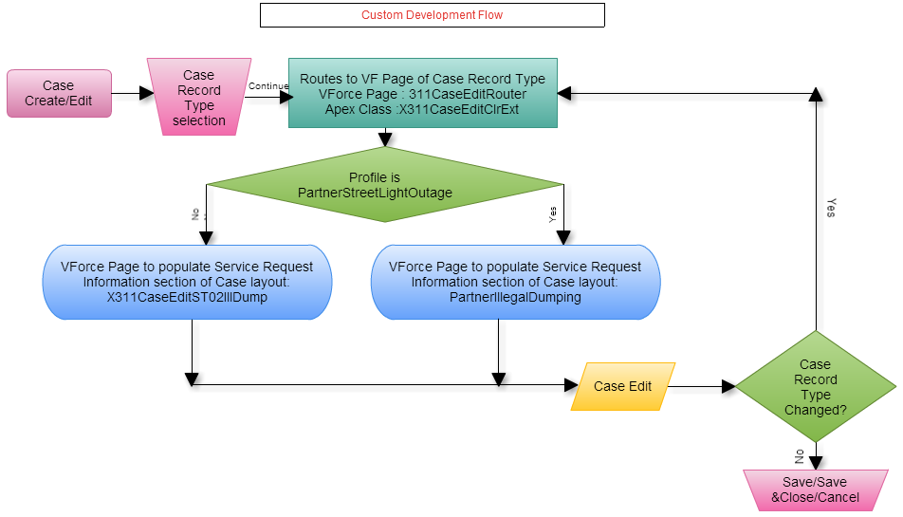

**Custom Flow :** For standard button New/Edit button is replaced with a custom Visualforce Page **X311CaseEditRouter**. All the Visual force pages and related extensions are defined as follows.

**Visual Force Page : X311CaseEditRouter**

**Purpose:**  To route to SR specific Visual force page.

<apex:page standardcontroller="Case" extensions="X311CaseEditClrExt" action="{!redir}">

</apex:page>

**Apex Class : X311CaseEditClrExt**

public PageReference redir() {

* + - 1. Get current page parameters.
      2. Get the relevant Page depending on the Profile and Record Type(X311CaseEditNS01Graffiti or PartnerGraffitiRemoval)..
      3. Redirect to the page with parameters.

}

**Visual Force Page : X311CaseEditST02IllDump**

<apex:page standardcontroller="Case">

<apex:composition template="X311CaseEdit">

<apex:define name="typeSpecific">

<apex:pageblocksection title="Service Request Information" showheader="true" collapsible="true" columns="2">

**ILLEGAL DUMPING SPECEFIC FIELDS**

</apex:pageblocksection>

</apex:define>

</apex:composition>

</apex:page>

**Visual Force Page : X311CaseEdit**

<apex:page standardcontroller="Case" extensions="X311CaseEditClrExt">

<apex:pageblock mode="edit">

<apex:pageblocksection title="Department Details">

</apex:pageblocksection>

<apex:pageblocksection title="Case Information">

</apex:pageblocksection>

<apex:pageblocksection title="Service Request Location">

</apex:pageblocksection>

<apex:inputTextArea id="caseInternalComments" >

</apex:pageblocksection>

<apex:pageblocksection title="Description Information">

</apex:pageblocksection>

<apex:pageblock>

</apex:page>

**Visual Force Page : PartnerIllegalDumping**

<apex:page standardcontroller="Case" extensions="X311CaseEditClrExt">

<apex:pageblock mode="edit">

<apex:pageblocksection title="Department Details">

</apex:pageblocksection>

<apex:pageblocksection title="Case Information">

</apex:pageblocksection>

<apex:pageblocksection title="Service Request Location">

</apex:pageblocksection>

<apex:inputTextArea id="caseInternalComments" >

</apex:pageblocksection>

<apex:pageblocksection title="Service Request Information" showheader="true" collapsible="true" columns="2">

**ILLEGAL DUMPING SPECEFIC FIELDS**

</apex:pageblocksection>

<apex:pageblocksection title="Description Information">

</apex:pageblocksection>

<apex:pageblock>

</apex:page>

|  |  |  |
| --- | --- | --- |
| **Trigger Name** | **Object** | **Description** |
| CalculateBusinessHoursAges | Case | Calculates the total business hours between when a case was opened and when it was closed and then populates “Case Age in Business Hours” field, which is displayed in the “Age to Close in Business Hours” field shown within the “Resolution Information” section of the case |
| Account_Name_Update | Contact | When a new Contact is created during the case creation process, the system does not allow for an Account to be associated to the Contact, yet Account is a required field for a Contact. Whenever a new Contact is created without an Account, this trigger will associate the Account record with Name = “City of Hampton” to the Contact record |

**Apex Code:**

**Force.com sites:**

**Javascripts:**

**Web Service/API Code:**

**Customer Portals:**

**Communities:** Community Partner Self-Service Portal

**Site.com:**

**Third Party Applications:**  Survey Force, Sales for Social Media & Call Center Console

**Other:**

**Layout**

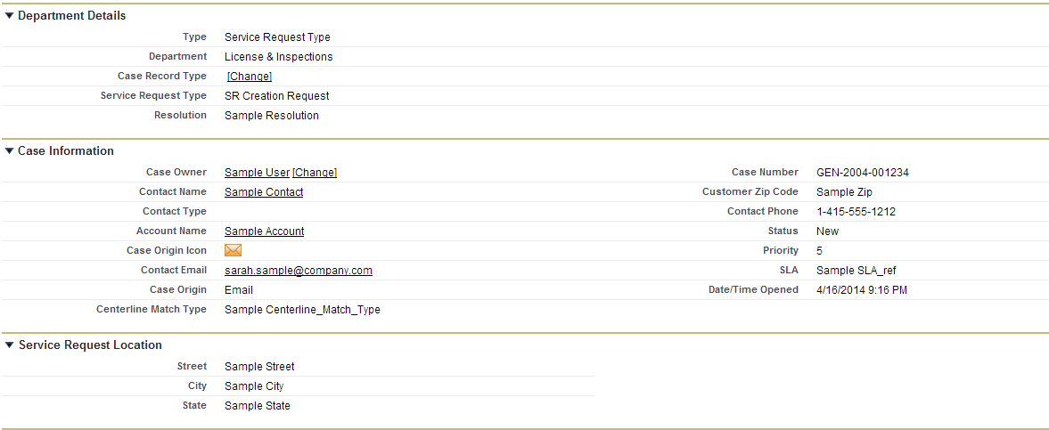

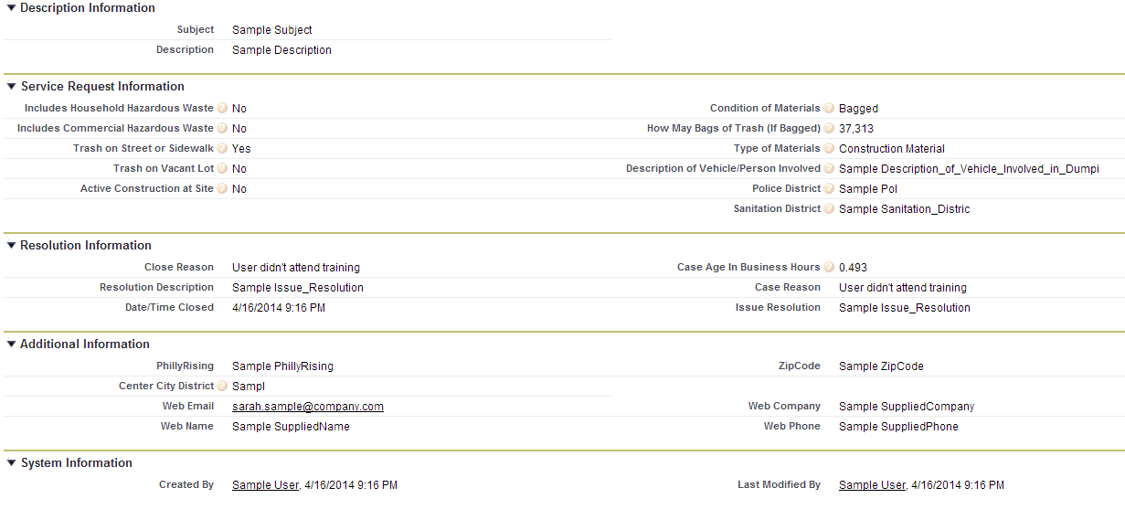

Related Lists :

* Articles
* Related Cases
* Open Activities
* Activity History
* Case Comments
* Case History
* Attachments

# 4 – STANDARD CASE FIELDS

|  |
| --- |
| 4.1 DEPARTMENT DETAILS SECTION |

|  |  |  |  |  |  |  |  |  |  |  |  |
| --- | --- | --- | --- | --- | --- | --- | --- | --- | --- | --- | --- |
| **Field Label** | **Field Name** | **Field Type** | **Custom** | **Default** | **Required** | **Unique** | **Read Only** | **External ID** | **Validation** | **History** | **Comments** |
| Type | Type | Picklist  **Values:** Service Request Type, Information Request Type, Directory Services | N | Service Request Type | Y |  | N | N | None | Y | Field is initially auto-populated based on the Case Record Type being created. If this value is manually changed, it will result in a new Field Layout based on the new Case Record Type. |
| Department | Department__c | Picklist  **Values:** Neighborhood Services | Y | Service Request Type | Y |  | N |  | None | N | Department will be automatically set based on Service Request Type. For an Information Request, this field will be automatically populated by the article. For Directory Services the field will default to 311 Services. |
| Service Request Type | Service_Request_Type__c | Picklist  **Values:** Graffiti Removal | Y | Graffiti Removal | Y |  | N |  | None | Y | This field is initially auto-populated based on the Case Record Type chosen when creating the case. If this value is changed, it could result in a new Field Layout based on the new Case Record Type chosen.  If any value in the Other Case Information systems indicates that this should not be forwarded to another department as a Service Request, a value of “Request Not Required” will be assigned to this field, which will indicate that the Case should be closed upon save without being assigned to a queue. |

|  |
| --- |
| 4.2 CASE DETAIL/INFORMATION SECTION |

**NOTE :** Section Header has to be “Case Information” in the layout when case is created or opened for modification. Other wise, Section Header is “Case Detail” .

| **Field Label** | **Field Name** | **Field Type** | **Custom** | **Default** | **Required** | **Unique** | **Read Only** | **External ID** | | **Validation** | **History** | **Comments** |
| --- | --- | --- | --- | --- | --- | --- | --- | --- | --- | --- | --- | --- |
| Case Owner | Owner | Lookup(User,Queue) | N |  | N |  | N | N | None | | Y | When a case is created this field is set to the User creating the case. Upon save, the Standard Case Assignment Rule is executed and this field is updated to a Queue based on the case’s Service Request Type. Once the case is saved this field can be manually changed by a user. |
| Case Number | CaseNumber | Auto Number | N |  | N | Y | Y | N | None | | N | The system automatically populates this field when a case is created. |
| Caller Zip Code | Caller_zip_code__c | Lookup(Contact) | Y |  | Y |  | N | N | None | | Y | This field will be populated by the Zip Code in the Contact record if one is associated with the case, otherwise the agent may populate it with a number from the caller. |
| Contact Name | Contact | Lookup(Account) | N |  | N |  | N | N | None | | Y | This field contains the Contact requesting the service. Ideally every case should have an associated contact. |
| Account Name | Account | Lookup(Account) | N |  | N |  | N | N | None | | N | This field contains the Account associated with the Contact record. |
| Parent Case | Parent | Lookup(Account) | N |  | N |  | N | N | None | | N | Two cases can be associated to each other via a parent/child relationship. This field identifies the “Parent” case. “Child” cases are displayed in the “Related Cases” Related List section for the “Parent” case. |
| Case Origin icon | Origin | Formula(Text) | Y |  | N |  | Y | N | None | | N | Shows an image representing the value in the Case Origin field. The formula for this field is: IMAGE(  CASE( Origin,  "Email", "https://<SalesforceOrg>.content.force.com/servlet/servlet.FileDownload?file=015K0000000238q",  "Phone", "https://<SalesforceOrg>.content.force.com/servlet/servlet.FileDownload?file=015K0000000238R",  "Web", "https://<SalesforceOrg>.content.force.com/servlet/servlet.FileDownload?file=015K000000023QL",  "/s.gif"),  "Origin Flag") |
| Contact Phone | ContactPhone | Phone | N |  | N |  | Y | N | None | | N | This display-only field is from the “Phone” field on the Contact record associated to the case. |
| Contact Email | ContactEmail | Email | N |  | N |  | Y | N | None | | N | This display-only field is from the “Email” field on the Contact record associated to the case. |
| Status | Status | Picklist  **Values:** On Hold, Escalated, Closed, New, In-Progress | N | New | Y |  | N | N | None | | Y | This required field defines the status of the case.   * “New” is the default value when creating a case. * All values except “Closed” are available when creating or editing a case.   “Closed” is the only value that can be selected when the “Close Case” button is used. |
| Case Origin | Origin | Picklist  **Values:** Email, Phone, Web | N | Phone |  | Y | N | N | None | | Y | This optional field provides the in-depth description of the case. |
| Priority | Priority | Picklist  **Values:** 1,2,3,4,5,6,7,8,9 | N | 5 |  | N | N | N | None | | N | This field allows a user to easily create a Comment while creating or editing a case. The data entered in this field will be used by the system to create a Comment record that will be displayed in the “Case Comments” Related List section of the case. |

## 

|  |
| --- |
| 4.3 SERVICE REQUEST LOCATION SECTION |

|  |  |  |  |  |  |  |  |  |  |  |  |
| --- | --- | --- | --- | --- | --- | --- | --- | --- | --- | --- | --- |
| **Field Label** | **Field Name** | **Field Type** | **Custom** | **Default** | **Required** | **Unique** | **Read Only** | **External ID** | **Validation** | **History** | **Comments** |
| Street | Street__c | Text(255) | Y |  | N |  | N |  |  |  | Street of the Service Request Location. Also see Standard Workflow Rules. |
| City | City__c | Text(255) | Y |  | N |  | N |  |  |  | City of the Service Request Location. Also see Standard Workflow Rules. |
| State | State__c | Text(255) | Y |  | N |  | N |  |  |  | State of the Service Request Location. Also see Standard Workflow Rules. |

|  |
| --- |
| 4.4 CASE LOCATION SECTION |

Defined in GIS Integration Detailed Design Document.

|  |
| --- |
| 4.5 DESCRIPTION INFORMATION SECTION |

|  |  |  |  |  |  |  |  |  |  |  |
| --- | --- | --- | --- | --- | --- | --- | --- | --- | --- | --- |
| **Field Label** | **Field Name** | **Field Type** | **Custom** | **Default** | **Required** | **Read Only** | **External ID** | **Validation** | **History** | **Comments** |
| Subject | Subject | Text(255) | N |  | Y | N |  |  | Y | If this field is populated when creating a new case, the system will find and display Knowledgebase Articles using the content in the “Subject” field. |
| Description | Description | Long Text Area(32000) | N |  | Y | N |  |  | Y | This optional field provides the in-depth description of the case. |
| Internal Comments | Comments | Text Area(4000) | N |  | N | N |  |  | N | This field allows users to enter a Comment while creating or editing a case. Data entered in this field will be used by the system to create a Comment record that will be displayed in the “Case Comments” Related List section of the case. |

|  |
| --- |
| 4.6 RESOLUTION INFORMATION SECTION |

NOTE: Case Detail page have these fields only be populated if the case is “closed”.

| **Field Label** | **Field Name** | **Field Type** | **Custom** | **Default** | **Required** | **Read Only** | **External ID** | **Validation** | **History** | **Comments** |
| --- | --- | --- | --- | --- | --- | --- | --- | --- | --- | --- |
| Close Reason | Close_Reason__c | Formula (Text) Formula : TEXT(Reason) | Y |  | N | Y |  |  | N |  |
| Resolution Description | Resolution_Description__c | Formula (Text) Formula : TEXT(Issue_Resolution__c) | Y |  | N | Y |  |  | N |  |
| Date/Time Closed | ClosedDate | Date/Time | N |  | N | Y |  |  | N |  |
| Age to Close in Business Hours | Age_to_Close_in_Business_Hours__c | Formula(Number) | Y |  | N | Y |  |  | N | CalculateBusinessHoursAges trigger would update this field |
|  |  |  |  |  |  |  |  |  |  |  |

NOTE: Following fields is shown in Resolution Info section.

|  |  |  |  |  |  |  |  |  |  |  |
| --- | --- | --- | --- | --- | --- | --- | --- | --- | --- | --- |
| **Field Label** | **Field Name** | **Field Type** | **Custom** | **Default** | **Required** | **Read Only** | **External ID** | **Validation** | **History** | **Comments** |
| Case Age in Business Hours | Case_Age_In_Business_Hours__c | Number(15,3) | N |  | N | Y |  |  | Y | CalculateBusinessHoursAges trigger would update this field |
| Case Reason | Reason | Picklist Values: Emergency Call, Invalid, Other, Question Answered | N | Question Answered | Y | N |  |  | Y |  |
| Issue Resolution | Issue_Resolution__c | Text Area(255) | Y |  | N | N |  |  | Y |  |

## 

|  |
| --- |
| 4.6 WEB INFORMATION SECTION |

NOTE: Section is shown only when the case is created through social media channels.

| **Field Label** | **Field Name** | **Field Type** | **Custom** | **Default** | **Required** | **Read Only** | **External ID** | **Validation** | **History** | **Comments** |
| --- | --- | --- | --- | --- | --- | --- | --- | --- | --- | --- |
| Web Email | SuppliedEmail | Email | N |  | N | Y |  |  | N |  |
| Web Name | SuppliedName | Text(80) | N |  | N | Y |  |  | N |  |
| Web Company | SuppliedCompany | Text(80) | N |  | N | Y |  |  | N |  |
| Web Phone | SuppliedPhone | Text(40) | N |  | N | Y |  |  | N |  |

|  |  |  |  |  |  |  |  |
| --- | --- | --- | --- | --- | --- | --- | --- |
| 4.7 SYSTEM INFORMATION SECTION | | | | | | | |
| **Field Label** | | **Field Name** | **Field Type** | **Custom** | **Default** | **Required** | **Read Only** | **External ID** | | **Validation** | **History** | **Comments** |
| Created By | | CreatedBy | Lookup(User) | N |  | N | Y |  | |  | N |  |
| Last Modified By | | LastModifiedBy | Lookup(User) | N |  | N | Y |  | |  | N |  |

Additional comments: